Booking Instructions
To purchase memberships, book fishing swims and accommodation, please do the following steps:
Sign up for a FREE swimbooker account.
Go to swimbooker.com Book Fishing Lakes & Day Tickets Near You | swimbooker
Create a free account – the green button
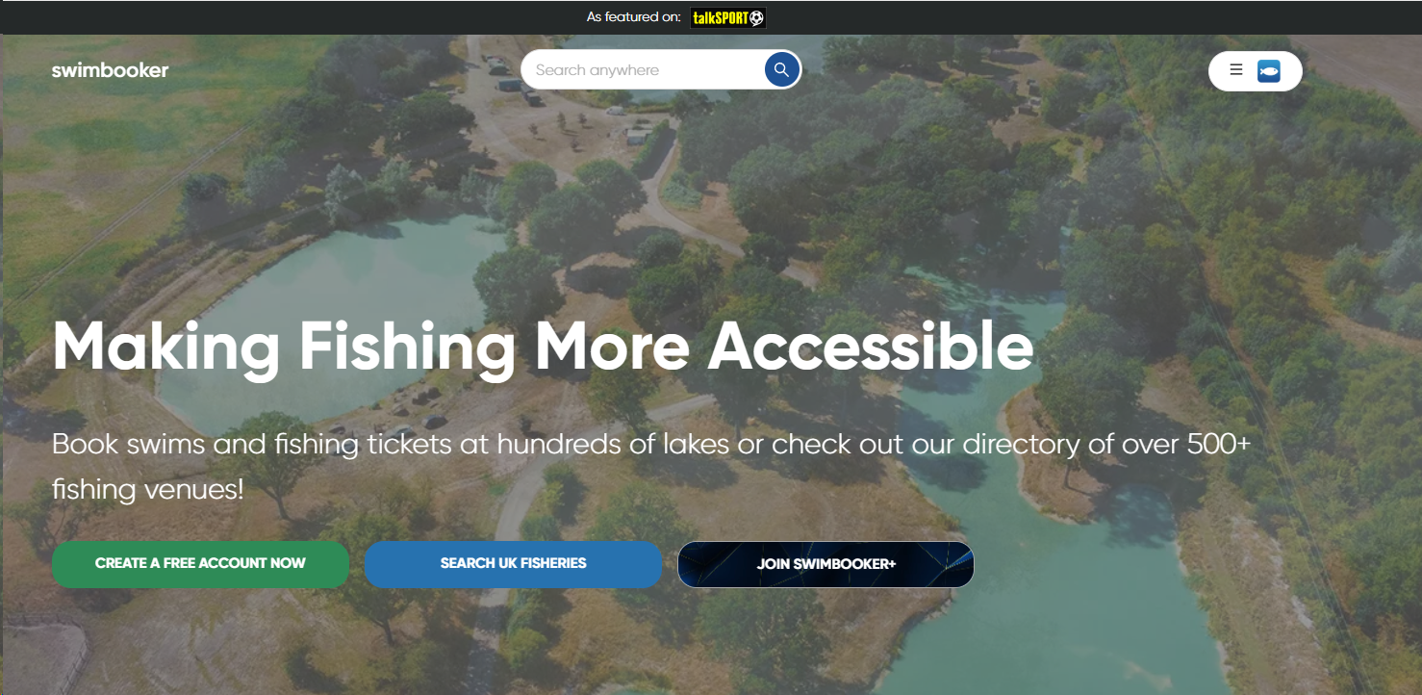 | 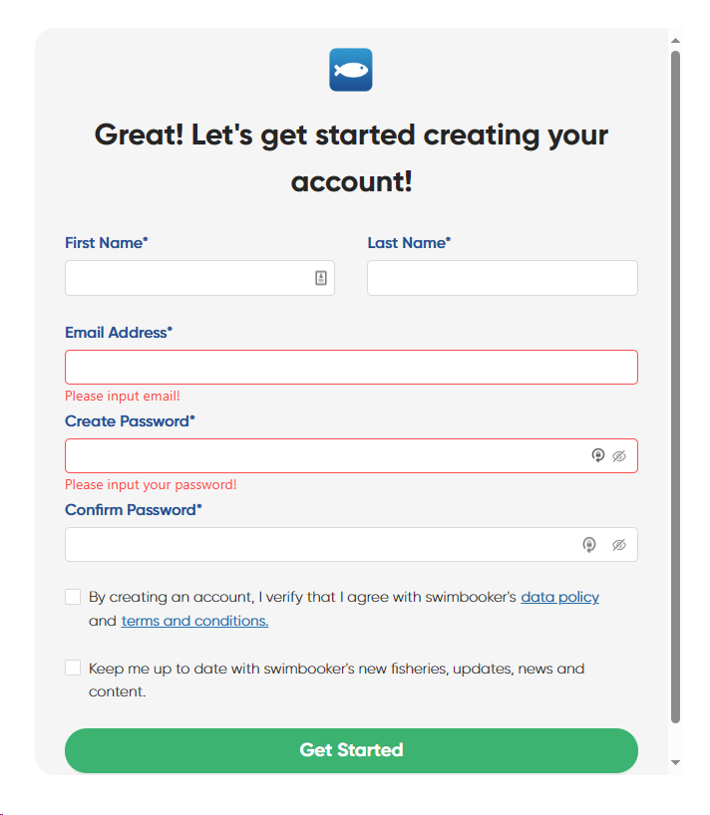

You will receive an email to verify your account, once verified you will get a second email to confirm your subscription.

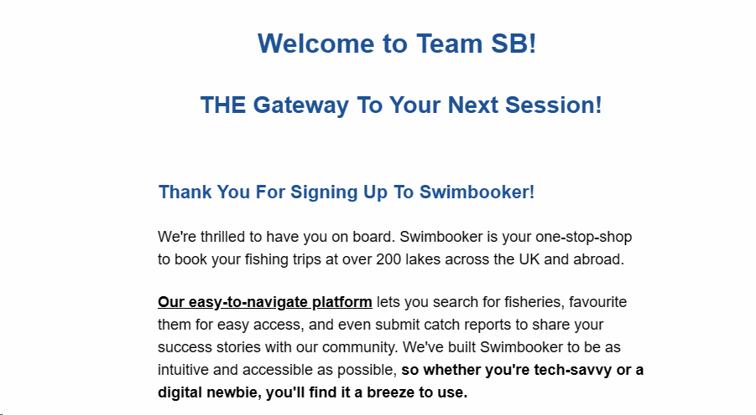

You can then search Swimbooker for Manor Fisheries, click on the profile and from there you can purchase your membership, swims and accommodation.
Alternatively, this link will take you straight there
Manor Fisheries Profile | Book Fishing & Learn More About The Fishery (swimbooker.com)

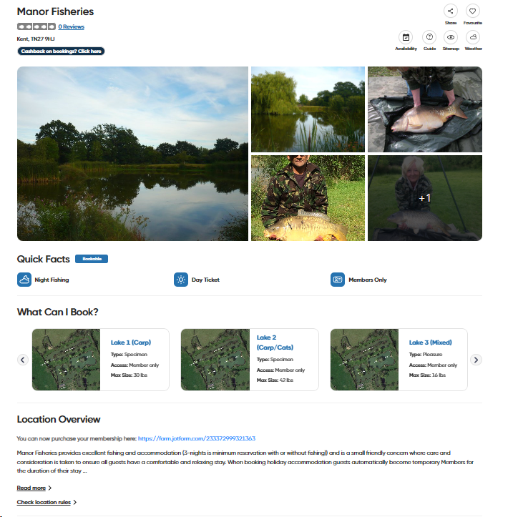  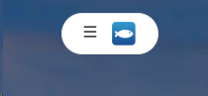  Point to note:  Click on the fish icon on the top right hand corner to log into your Account! | Make sure you purchase your membership first.  In the Location Overview section, you will see a link to purchase your membership.  You are unable to place any bookings unless you have a membership.  Once you purchase your membership, you will then receive another email and when you create the profile, you will again be asked to verify your email…the email suggests you have forgotten our password, ignore that but do click to change password and then enter your swimbooker password.  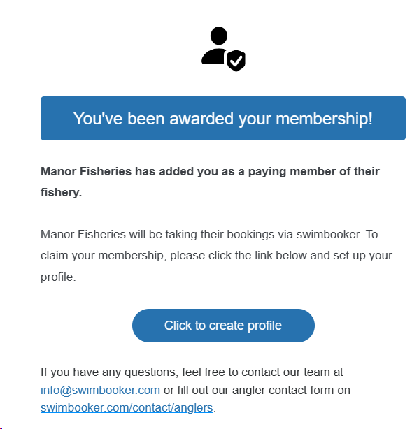

That’s the hard work now done!!
Every time you want to visit, simply go to the Manor Fisheries profile page on Swimbooker, make sure you are logged-in as Swimbooker will then recognise you as a member and you can go ahead and book your swims and accommodation by clicking the green ‘Book now’ button at the bottom of the page.
Manor Fisheries Profile | Book Fishing & Learn More About The Fishery (swimbooker.com)

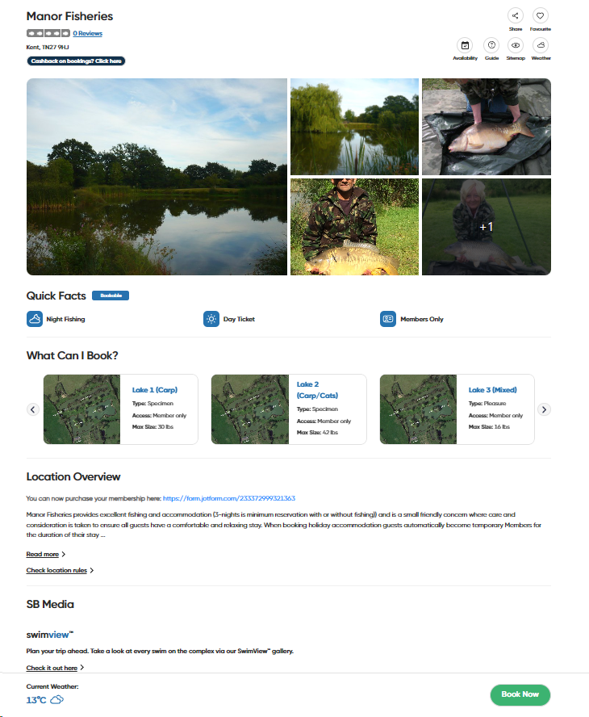 | Firstly, select your preferred lake or accommodation.  You can only purchase one ticket, per membership.  Then select your arrival date (and departure if staying longer than one day).  Select your arrival and departure times.  Complete your details and the number of rods you will have.  Then accept terms and conditions, before proceeding to the payment page.  If you have booked accommodation, you can then go on to place your bookings for the lakes you wish to fish during your stay.  Thank you for your custom!

